The following comes from getting the errors in my Git-Bash shell.

Some CMake commands don’t work because “sh.exe must not be in your path”

See the following when I type

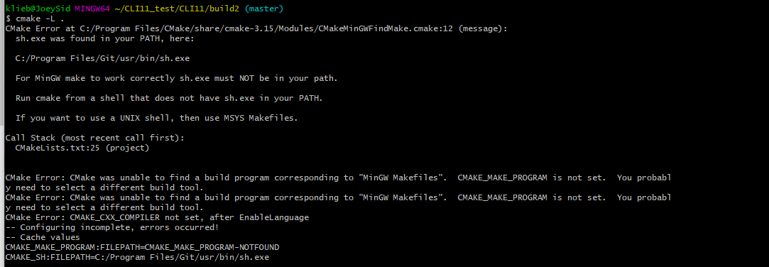

cmake -L .

CMake Error at C:/Program Files/CMake/share/cmake-3.15/Modules/CMakeMinGWFindMake.cmake:12 (message):

sh.exe was found in your PATH, here:

C:/Program Files/Git/usr/bin/sh.exe

For MinGW make to work correctly sh.exe must NOT be in your path.

Run cmake from a shell that does not have sh.exe in your PATH.

If you want to use a UNIX shell, then use MSYS Makefiles.

Call Stack (most recent call first):

CMakeLists.txt:25 (project)

CMake Error: CMake was unable to find a build program corresponding to "MinGW Makefiles". CMAKE_MAKE_PROGRAM is not set. You probably need to select a different build tool.

CMake Error: CMake was unable to find a build program corresponding to "MinGW Makefiles". CMAKE_MAKE_PROGRAM is not set. You probably need to select a different build tool.

CMake Error: CMAKE_CXX_COMPILER not set, after EnableLanguage

-- Configuring incomplete, errors occurred!

-- Cache values

CMAKE_MAKE_PROGRAM:FILEPATH=CMAKE_MAKE_PROGRAM-NOTFOUND

CMAKE_SH:FILEPATH=C:/Program Files/Git/usr/bin/sh.exe

When I looked up how to solve this, suggested PATH changes.

I think I still need to download MinGW

MinGW = Minimalist GNU for Windows. It’s a bunch of Window ports of GNU native tools like GCC and Make so it is a Windows port of the GCC compiler

Qt supports MinGW as a platform on Windows

Qt supports Visual Studio compiler too!

Qt is a free cross-platform alternative to Visual Studio

|  |
| --- |
| version: 1.1.0-{build}  environment:  matrix:  - GENERATOR: MinGW Makefiles  - GENERATOR: Visual Studio 14 2015  - GENERATOR: Visual Studio 14 2015 Win64  configuration: Debug  before_build:  # Workaround for CMake not wanting sh.exe on PATH for MinGW  - set PATH=%PATH:C:\Program Files (x86)\Git\bin;=%  - set PATH=C:\MinGW\bin;%PATH%  - mkdir build  - cd build  - cmake -DCMAKE_BUILD_TYPE=%CONFIGURATION% -G "%GENERATOR%" ..  build_script: cmake --build . --config %CONFIGURATION%  test_script: ctest -V . |

Currently I do not have MinGW installed in my machine to be used as a compiler or generator

To see what your path is set to Use

echo $PATH

to